11.59:
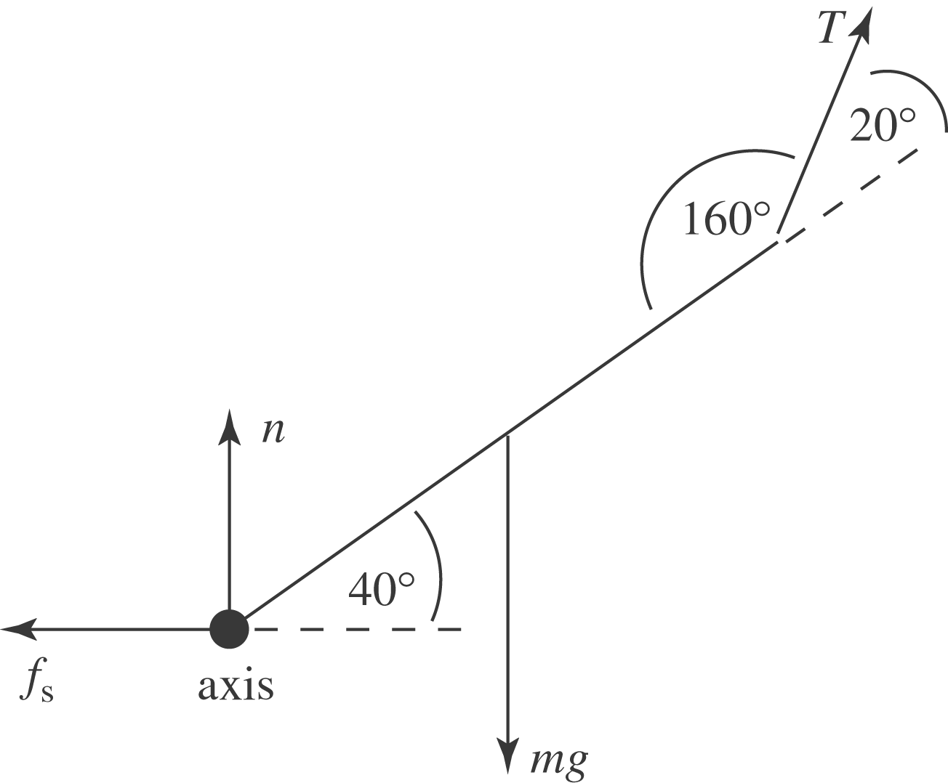
a) 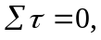 axis at lower end of beam
Let the length of the beam be L.

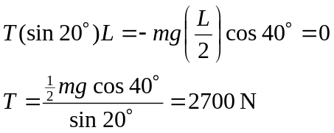

b) Take +y upward.

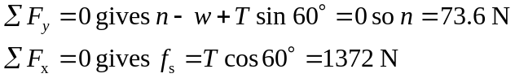
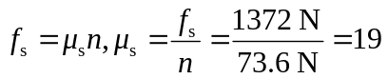

The floor must be very rough for the beam not to slip.

